Wage Equity In Higher Education

Veneeya Kinion
Colorado State University Global
MIS 581: Capstone – Business Intelligence and Data Analytics
Dr. Kimberly Ford
July 4, 2021

Abstract
Growth of legislative mandates prompts inquiries for evidence based assessment and analysis of wage equity between gender and ethnic groups. The wage equity act requires educational institutions to demonstrate, through an evaluative process, the wage equity analysis of Higher Education workforce.
The examination of gender and ethnicity gap at higher education institution adds transparency to issues organizations face in leveling the employee gender gap playing field.
This study investigates the relationship between gender and ethnic populations wage equity in similar positions across an educational organization. In this context, ethnic groups follow the same eight grouping as defined by the National Center for Educational Statistics (NCES).
Measures of diversity are present across positions in gender and people of color. To show evidence of the overall gender wage gap, descriptive and empirical statistical methods answer the question of pay equity across gender, ethnicity and position in Higher Education.
Select variables from a collection of secondary Human Resource data, salary, gender, ethnicity and current position were analyzed for differences. Quantitative statistical analysis were assessed for statistical significance of gap.
The results showed female employee’s median wages is not significantly different from that of males in the same position. Employees of color median wage are lower than that of employees in the same position, not of color. There is enough evidence to conclude that there is no signiﬁcant diﬀerence in median wages between male and female employees in same position. Contrary to the evaluation of gender, ethnic groups did not produce enough evidence to conclude that diﬀerence exist in median wages between employees of color compared to other employees not of color.
TABLE OF CONTENTS
Introduction: Wage Equity In Higher Education 4
objectives 4
OVERVIEW 5
RESEARCH HYPOTHESIS 5
LITERATURE REVEW 6
rESEARCH DESIGN 9
Methodology 10
Research Method 11
Limitations 11
Ethical Considerations 12
FINDINGS 13
cONCLUSION 19
RECOMMDATIONS 20
References 21

Wage Equity In Higher Education
Colorado’s recent wage equity act requires educational institutions within the state of Colorado to demonstrate, through an evaluative process, the wage equity analysis of workforce and model for adjusting any salary disparities. Elaborating on academic institutions social debate on pay equity within the industry, the study intention is to focus on researching the equity of wage across genders and racial groups in higher education instructional sectors.
A broader understanding of the Higher Education environment across the state of Colorado will deliver a largesse of benchmark information with peer institutions. Expanding the knowledge base of equity among divers population in education, an analysis will assist with an improved understanding of inequity across industry and bring to light areas that need attention. The research will contribute to a greater body of knowledge on diversity by comparing institutions wage equity between genders and persons of color.
The evaluation process of wage and person demographic data will follow necessary precautions and safeguards to ensure the proper handling and security of the data. Protecting the anonymity and privacy in the collection of confidential information in the forefront of study.
Objectives
State mandates require an evaluation of wage equity for institutions of higher education. The following research will undergo descriptive and empirical statistical methods to answer the question of pay equity across gender, ethnicity and position at Mountain Community College. Data from the institution human resource database, evaluated for significant relationships to assess diversity across the college’s positions for pay equity between gender and ethnic groups in same positions. Identified gaps presented for further salary adjustments at individual levels to address imbalance at the position level.

Overview
The gender wage gap has been rigorously explored for scores of years. Studies have demonstrated to drive an effectual change in addressing bias and closing gaps of gender inequity through continuous monitoring and evaluation. The monitoring of data to insure equity, placement of legislative action and establishing a set of recommendations to embed into organization requirements of affirmative action.
Addressing a the legislative requirement of demonstration of wage equity at institutions of effectual change in addressing bias and closing gaps of gender inequity using visual output plots produced using SAS (SAS® OnDemand for Academics), to present relationships.
Research Hypothesis
The formulation of business question and testing will help to move Mountain Community College toward greater understanding of wage equity that will enable them to answer the following questions and test them with the use of analytics. Diversity is present across positions in gender and people of color are represented across all levels and positions. To show evidence of the overall gender wage gap, a visual display of the diﬀerence in median wage for men and women as well as test for signiﬁcance. The following questions and hypothesis will be examined in the study.
RQ 1: Female employee’s median wages is lower than that of males in same position?
H₀ 1: There is no signiﬁcant diﬀerence in median wages between male and female employees in same position, and
Hα 1: There is signiﬁcant diﬀerence in median wages between male and female employees in same position.
RQ 2: Employees of color median wages is lower than that of employees not of color?
H₀ 2: There is no signiﬁcant diﬀerence in median wages between employees of color compared to employees not of color in same position, and
Hα 2: There is signiﬁcant diﬀerence in median wages between employees of color compared to other employees not of color in same position.
A null hypothesis, purports that no significant difference exists in a set of given observations. For the purpose of these tests, an evaluation of each of the employees’ salaries using the visual output plots produced using SAS (SAS® OnDemand for Academics), to show any relationship. It was noted by Chapman & Benis (2017) that the gender wage gap has experienced variability over time mostly brought on by economic, social and political environments in history. The analysis will help discover if the current gender wage data is in the rise or fall state of Chapman & Benis (2017) observation at Mountain Community College.
Literature Review
The following literature review surveys existing studies relating to gender gap issues that are relevant to the present study. A number of theoretical contributions explaining the importance of monitoring and evaluating wage inequality across demographics of working population that affect legislation, employee turnover and legal claims of discrimination.
Blau & Kahn (2017) explorations of psychological attributes on gender pay gap outline human factors that can influence the gender gap. The focus of research on full-time workers and those with substantial labor-force attachment over the year is designed to identify female and male workers with similar levels of labor-market commitment. Historic changes in gender gap and a decomposition of these changes in characteristics of schooling, experience, industry, occupation and union status are explained to demonstrate the extent of trends in the gender wage gap and their potential for further explanation of pay gap. The results of what Blau & Kahn (2017) call conventional human capital variables (education and labor-market experience) together did little to explain the gender wage gap. When controlling for psychological attributes the wage equity gap closes.
Blau & Kahn (2017) research is recognized as foundational in gender gap studies, specific to psychological factors that influence the wage gap. It is one of the top cited research publication and contributor to understanding the consideration of other influential factors besides psychological factors in the gender wage gap. Analytic procedures and calculations for evaluating the gender pay gap are used in comparable fashion to this study with college’s data and wage gaps between genders. Blau & Kahn (2017) identified an ongoing unexplained factor to gender wage gap that merely suggests the existence of labor-market discrimination.
To better understand the gap among workers, researchers have increasingly studied speciﬁc ﬁelds or occupations that provide new insights into the explanations and potential solutions for the gender wage gap. Chen & Crown (2019) assessed gender wage gap at a state university that is often regarded as a harbinger for political and consumer trends, contributing useful insight on gender pay disparities in higher education.
Annual information on employee’s salary, gender, age, faculty rank, start year at the institution, full-time equivalency (FTE) status, and tenure status attributes of data used in study are commonly collected at educational institutions. Utilizing salary and human resources data from the University, Chen & Crown (2019) estimate the gender wage gap through examination of t-statistics for test of equality of mean. A portion of the gender wage gap study at the University cannot be explained by differences in observed characteristics. The examination of faculty salary in higher education are noted among challenges of how to address multiple appointments, years, rank and other unique barriers to academia. The examination of gender gap at public institution adds transparency to issues all organizations face in leveling the employee gender gap playing field. Differences in the treatment of multiple appointments, part-time appointments, and non-academic appointments are shown to have signiﬁcant impacts on the estimated wage gap. The industry chosen by Chen & Crown (2019) for researching gender gap is comparable to current research and contributes to the overall understanding of issues higher education faces with the evaluation of gaps between genders in positions and ranks.
Miller et al. (2018) study of “The Simple Truth About the Gender Pay Gap”, outlines benefits to closing the gender pay gap that would have a large impact on women, their families, and the economy. To present gender wage gap Miller et al. (2018), show breakdowns of the gender pay gap by race and ethnicity to discuss the causes of the gender pay gap. Common framework for evaluating wage gaps are applied where earnings for women of different racial groups is usually calculated with white, non-Hispanic men as the comparison group are methods that will be applied to current study. Miller et al. (2018) identifies women working full time are typically paid less than men are in the same group. Additionally, the analysis demonstrates women experience a pay gap in every state, at every age, across all ethnic groups, and in nearly every occupation. The research contributes to the literature by demonstrating that women experience pay gap in nearly all occupations in spite of educational qualifications and setting.
Factors such as race, class, sexual orientation, and disability mean different women have different opportunities and advantages. Once women are in the workforce, women and men face gendered perceptions, expectations, and other biases. The data collected by Miller et al. (2018) demonstrates gaps still exist nationally and efforts to assess and embed change processes are still needed. Contrary to the use of aggregate data, the research highlights the work needed to transcend inequities.
As more employers are relying on group work, Sarsons (2017) research explores if there are differences of promotion between demographics when working in groups or on solo projects. Group work and credit with solo or co-authored contribution papers widen the gap or shrinks for women. The research study group demonstrated that women faculty authoring solo or collaboratively had less chance of receiving tenure unless women worked with other women in co-authorship. Men have equal probability of receiving tenure regardless of coauthoring or individually author work, identifying how gender plays a role in promotion decisions.
Sarsons (2017) noted that many of today’s industry and occupations require group work. The tech industry, one example that is very male-dominated field of work could result in fewer women moving up the career ladder as a result from group work environments. The research collaborates with other research in higher education of promotion gender differences and underlying findings of gender differences between pay and rise up career ladder. Awareness of a long-standing gap prompts the necessity to evaluate and monitor factors that affect the gender gap. Some drawbacks to the study are the assumptions that group work in industry and higher education have similarities. This researcher’s position is theoretical and implies co-authorship in higher education and group work applies to the greater population.
Research Design
The research design chosen for this study is a quantitative research design. Use of descriptive and inferential statistics in the evaluation of the data to identify relationships and focus on a systematic pursuit of the truth. The use of quantitative research for the process of collecting and analyzing numerical data is appropriate based on data type and can be used to find patterns and averages.
Research Methodology
The collection of data from a secondary source of Human Resource data will address the business question and test the hypothesis of wage equity between gender, ethnic groups and positions.
Working with Mountain Community College, wage data for current employees along with demographic and currently held positions were gathered to help identify wage equity between groups and answer question of equity for the institution.
Data collected for the study was obtained from Mountain Community College database of all currently employed fulltime staff. Personnel information collected from individuals by college human resource hiring staff upon employment at the institution.
Use of SQL with college’s SQL server was used to query human resource databases, select and extract records on more than 400 current full-time employees. A minimal number of selected variables were chosen to answer specific research question to ensure privacy and maintain confidentiality of the sensitive information. Variable selection includes salary, gender, ethnicity information and current position.
Initial scan of the data for missing data and type was first performed for quality and completeness of the information. SAS PROC REG will be used as the primary tool for analysis. First evaluation of data will be review of descriptive statistics on all attributes. Next, the use of SAS linear regression to evaluate the salary data for each position, ethnicity and gender for any significant relationships.
The sensitive nature of the data require the anonymizing of individual identifiers to maintain levels of privacy. The use of a pseudonym for this attribute was produced with a simple random number generator.
Research Method
The collection of data from a secondary source of Human Resource data used to address the business question and test the hypothesis of wage equity between gender and ethnic groups. Collected data on employees from the higher education institution is categorical and numeric in nature. The use of quantitative statistical analysis methods will be applied to test relationships between variables and visual graphics to present findings.
To show evidence of the overall gender wage gap, a graphical display of the diﬀerence in annual median wage for men and women as well as tests for signiﬁcance will be performed. SAS PROC REG will be used as the primary tool for analysis using analysis of variance that will evaluate the salary data for each rank and gender. Given the structure of the current analysis and available data, the primary intention is attempting to research how every value of the independent variable (gender, ethnicity, position) is associated with a value of salary. As there are more than one independent explanatory variable, analysis of variance (ANOVA) is the most suitable model for this study. Use of ANOVA to compare means across groups of several explanatory variables to assess salary is used to estimate the relationship between two or more independent variables and one dependent variable.
Limitations
Studies of wage equity across gender, ethnicity, position and industry have been challenged by many social and psychological factors of the human condition. Limitations have encompassed factors of data availability, consistency, confidentiality and abstract physiological characteristics of humans. This study is not exempt from limitations and has comparable limitation of the subject matter.
Data obtained from educational institution was limited to a narrowed population of fulltime employees. Exclusion of part-time and temporary employees is not a full representation of all positions but eliminated do to unknown number of hours worked to produce a salary from hourly wage. Findings will be informative to the institution for full-time employee’s equity and finding solutions to address the part-time employee population missing wage data.
Ethical Considerations
Conscious recognition and primary considerations for a researcher are to identify the best ways to approach research work ethically. Additionally, safe and secure handling of sensitive data is paramount in the function of research. Data such as that from education institutions is awash with heightened security and privacy concerns that stress exigency with the use of this data.
Collection process for data, use of analysis tools and applying ethical research practices are concerns for the handling of confidential educational data from proprietary datasets. The data, such as that collected in this research study, will be anonymized for the evaluation of equity. Obscuring personally identifiable attributes and confidential information are best practice to protecting individuals while answering specific research questions.
Use of data that has an individual’s personal identifiable information included in research, will have processes in place to anonymized individuals, remove unnecessary information unrelated to research and securing of information. Process for mitigation and protecting individuals from potential loss or theft of the information, anonymization practices will be applied to identifiable attributes in dataset. Use of pseudonyms for unique personal identifiers one method applied in anonymizing data.
Guiding practices employed with the use of confidential data, educational wage data will be collection along with only data deemed necessary to answer the research question. The security, ethical handling and maintaining privacy an effort to minimize risk of identification and harm to research subjects.
Findings
Two software tools were used to gather and analyze the data for this study. The software used to analyze the data was SAS (SAS Studio, n.d.). The analysis was conducted after data was gathered using Microsoft SQL Server, SQL language to query institutions proprietary Human Resource database for current institutional employees, salary and demographic information. The analysis of the data was conducted with the use of descriptive statistics and binary logistic regression. All code for querying data and analysis can be located at the following link in GitHub.
Characteristics of the data were examined for data quality and anonymizing confidential information. The use of pseudonyms for all person identifiers was used to replace unique identifiers before uploading the file to SAS (SAS Studio, n.d.) for analysis. For this study, the target population comprised the current employed, full-time staff, salary and demographic information from the institution at the time of the data extract. The data was first assed for the assumptions of homogeneity and normality of sample and residuals before using data to answer the research questions. One salary outlier was discovered as poor fit with sample and removed prior to statistical analysis.
The institutions current full-time population of 426 employees, of which 62.6% are female (n= 267) and 37.3% male (n=159). In figure 1, the average wages for full-time female employees annually are $67,221 opposed to the average male salary of $77,779. Figure 2 shows the ethnic composition of the institutions employees. The institution has been historically heavy Anglo American, currently 78.4%, although in recent years, gains in more diverse ethnic groups, especially of Hispanic origins are emerging with 9.3% of staff represented in the dataset. Tableau dashboards for descriptive data can be located at the following links: https://public.tableau.com/app/profile/veneeya/viz/WageEquityforGenderEthnicity/EthnicityDashboard
Figure 1
Mean Salary of Men and Women
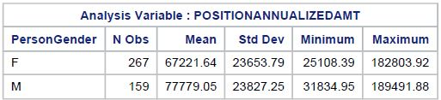
Figure 2
Mean Salary by Ethnicity
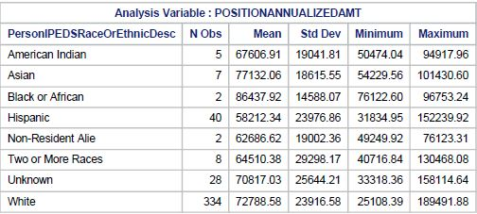
Two research questions explored and evaluated in the following data table analysis include research question 1.) Female employee’s mean wages are lower than that of males and the second research question 2.) Employees of color median wage is lower than that of employees not of color, are explored using Two-way ANOVA method. The following variables, gender and PositinoClassDesc data is categorical and evaluated to answer first research question. The method choice to address the gender wage gap with analysis of variance was determined based on the questions to be answered and the type of data.
A factorial ANOVA was conducted to compare the main effects of Gender and PositionClassDesc, the two independent variables as well as their interaction of effects on the dependent variable, PositinoAnnualizedAmt.
Figure 3
Overall fit P-value of Gender for Statistical Significance
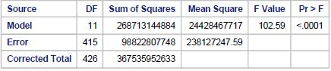
Figure 3 gives the result of the overall model. The p-value is less than or equal to the significance level of 0.05 at p=<0.001 indicating that at least one of the terms is significant. Concluding that an association exists but not which association. Figure 4 provides the ANOVA results broken down by main effects and interactions using Type III sum of squares.
Figure 4
Two Factor Analysis Type III ANOVA Table
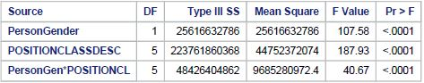
The AVOVA results from a Two-Factor Analysis in figure 4, shows that there is some evidence of interaction between the PersonGen*PositionClassDesc with a p-value <.0001. This means a rejection of the null hypothesis and accept the alternative hypothesis. There is definite, significant relationship between the two events. There is enough evidence to conclude that there is no signiﬁcant diﬀerence in median wages between male and female employees in same position. An interaction plot graph, seen in figure 5 is helpful in visualizing the results of the table data.
Figure 5
Interaction Plot for Gender and Position Annualized Amount
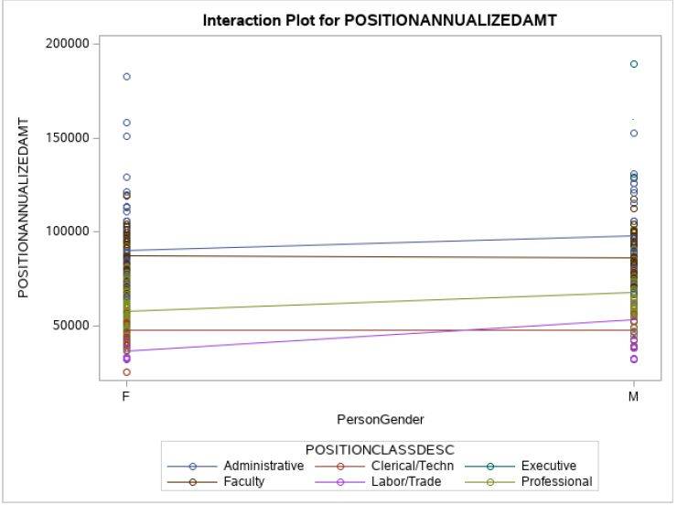
The Interaction plot in figure 5 shows data, along with the means, connected by lines. Here there are six different position groups, so six different group means. Those group means have been connected with lines. On the horizontal axis, there is PersonGender, female on the left and males on the right. In most cases, the mean mostly goes straight across. The amount by which it goes up depends upon position annualized amount variable. The graph further supports the finding that there is no significant interaction and indicates that PositionAnnualizedAmt are consistently higher for males in the same occupation. Gender and PositionClassDesc are statistically significant with p-values <.0001. The small value for our null hypothesis support that there are no difference across group.
Figure 6
Overall fit P-value of Ethnicity for Statistical Significance
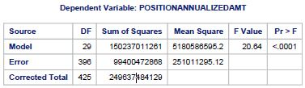
Figure 6 of the overall fit for ethnicity is significant at p-value=<.0001, indicating the presence of some differences in means. Moving to review figure 7 ANOVA, results are broken down by main effects and interactions using Type III sum of squares. Evidence of interaction between the PersonEthnicity*PositionClassDesc show a p-value = 0.7018 which means a failure to rejection the null hypothesis. There is not enough evidence to conclude for the alternative hypothesis that diﬀerence exist in median wages between employees of color compared to other employees not of color in same position.
An interaction plot graphic, seen in figure 7, is helpful in visualizing the results of the table data. Significance levels above the cut-off value demonstrate a failure to reject the null hypothesis, cannot accept the alternative hypothesis, but only find evidence against it.
Figure 7
Two Factor Analysis Type III ANOVA Table
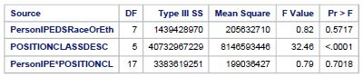
The Interaction plot in figure 8 shows a line plot overlaid with all the observations. There are eight different position groups, so eight different group means. Those group means have been connected with lines. On the horizontal axis, there is PersonEthnicity. Starting on the left with American Indian moving left across to whites on the right. In most cases, the mean mostly goes straight across with the exception of Administration and Labor trades. The Administration roles are low for American Indians and goes up for Black or African, then back down for Hispanic. The same can be seen for labor and trades for Hispanics then rise for Non-Resident Aliens, coming down again to Unknown ethnic group.

Figure 8
Interaction Plot for Ethnicity and Position Annualized Amount
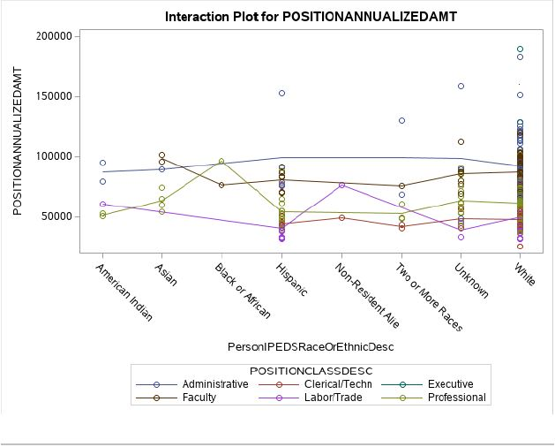
Conclusion
Many employers are becoming aware that both the mechanics and the implications of reporting equity in the workplace may be more significant than they anticipated. Some cases, shine a light on troubling inconsistencies, they are imperfect. The choice to address and meet these challenges is in the hands of the organization that discovers the social imbalances.
The research evaluation of current employees at Mountain Community College was central in addressing legislative requirement of demonstrated wage equity at institutions of higher education. The evaluation of current employees’ salaries and demographic explored two business questions and significance testing for wage equity of gender and ethnic groups among positions across the college. Changes at the individual organization level need to take place to help close gap. To that end, the methodology to analyze data used quantitative statistical analysis of gender, ethnicity and wage to assess statistical significance of gap along with graphics of the group means connected with lines to show the interaction between events.
There was enough evidence to conclude that there is no signiﬁcant diﬀerence in median wages between male and female employees in same position. With the evaluation of ethnicity there was not enough evidence to conclude that diﬀerence exist in median wages between employees of color compared to other employees not of color in same position.
Annual analysis can be done to understand the wage gap by applying different methods to test significant levels based on data type and size that any organization can initiate to close the equity gap.
Recommendations
The exploration of the wage equity among diverse groups is healthy exercises every human resources department should embed in diversity improvement processes. Diverse work cultures have demonstrated that diversity in the workplace builds strong internal business cultures, broadens customer loyalty, has greater presence worldwide and improves innovation and business success (Lazano & Escrich, 2016).
Testing of alternate models for data analysis are additional analytic recommendations toward finding a model that may be a better fit for identifying the wage equity gap. The addition of other data attributes, such as employee start date, may yield a stronger relationship between demographic attributes.
References
Blau, F. D., & Kahn, L. M. (2017). The gender wage gap: Extent, trends, and explanations. Journal of Economic Literature, 55(3), 789-865. https://doi.org/10.1257/jel.20160995
Chen, J. J., & Crown, D. (2019). The gender pay gap in academia: Evidence from the Ohio State University. American Journal of Agricultural Economics, 101(5), 1337-1352. https://doi.org/10.1093/ajae/aaz017
Chapman, S. J., & Benis, N. (2017). Ceteris non paribus: The intersectionality of gender, race, and region in the gender wage gap. Women's Studies International Forum, 65, 78-86. https://doi.org/10.1016/j.wsif.2017.10.001
Lozano, J. F., & Escrich, T. (2016). Cultural diversity in business: A critical reflection on the ideology of tolerance. Journal of Business Ethics, 142(4), 679-696. https://doi.org/10.1007/s10551-016-3113-y
Miller, K., Vagins, D., & Nielson, K. (2018). The Simple Truth about the Gender Pay Gap. AAUW.
SAS Studio. (n.d.). Version (9.4).
Sarsons, H. (2017). Recognition for group work: Gender differences in academia. American Economic Review, 107(5), 141-145. https://doi.org/10.1257/aer.p20171126
(n.d.). Tableau Public. https://www.tableau.com/community/public.

